Review Meeting Summary | Project Name: Development of Person Re-identification Algorithm for Basketball Ball-handlers in Complex Motion Scenarios
Meeting Time: 19:00, 5th June
Team Members: Ye Li, Chengyou Long, Siyu Lei
Main Content of the Meeting
This review meeting primarily assessed the project progress, code specifications, and management planning for "Basketball Ball-Handler Person Re-Identification," where the project team first introduced their progress, highlighting that the model was further optimized this month to improve the core metric mAP from 91.5% to 91.8% and Rank-1 from 94.3% to 94.9%, while also developing a Qt-based visualization interface tailored to the ReID workflow to facilitate the final presentation. Following this, the team presented the core code for four modules to the reviewers, including Overlapping Patch Embedding, SIE, JPM, and "AMP + Gradient Clipping + EMA," and finally outlined the project's management planning, which covered recent task durations, the completed sections of the WBS and RBS, as well as subsequent plans.
During the meeting, the reviewers gave high praise, noting that the project's core objectives are well-defined and expressing their approval of the project management, while also suggesting that the TTA section be extracted into a common function, additional comparative experiments be conducted, and trade-offs between accuracy and speed be considered.
Comments and Advice of the reviewers
Comments:
- The project management is exceptionally well-executed; with the project deadline fast approaching, your grasp of the schedule has been highly appropriate. At the same time, your ability to adapt requirements based on the project itself and reflect those changes back into the WBS and RBS is a major highlight.
- The PPT presentation as a whole was very well done, and the GUI design is excellent. Schedule management has been outstanding, and the updated RBS and Gantt charts are remarkably clear. It is particularly commendable that you could pinpoint short-term, mid-term, and long-term optimization directions with clear priority trade-offs.
- Since the last meeting, you have made a great deal of progress, and the overall schedule management feels very well-handled.
- The entire project arrangement is highly meticulous. You have successfully met the competition requirements, and your progress on the WBS and RBS is well on track.
- The core tasks are well-defined, and the analysis of various project aspects is both thorough and meticulously thought out.
- The project strikes an excellent balance between algorithm R&D and engineering implementation; it not only delivered on the dual metrics of accuracy and speed on schedule but also developed a practical graphical interface.
- The overall completion rate is quite high, showing noticeable progress in both technical and engineering aspects compared to the previous stage. Regarding model metrics, both mAP and Rank-1 have improved. Furthermore, this was not just a matter of simple hyperparameter tuning; rather, you introduced targeted strategies based on the specific scenario of basketball ball-handler re-identification—such as Reranking, ArcFace, multi-scale testing, EMA, motion blur, and illumination augmentation. This demonstrates that your optimization efforts were highly focused. Additionally, the GUI application and automated testing framework reflect strong engineering awareness, particularly the test alignment part, which helps ensure the comparability of subsequent experimental results.
Advice:
- If time permits in the future, you could include a demonstration of hard negative examples.
- The TTA code in three different places should be extracted into a common function to avoid extensive duplication.
- You could place more emphasis on milestone-related content and slightly scale back the detailed descriptions of specific design technologies.
- Moving forward, the most critical focus area should be the "trade-off between metric improvement and computational cost." Currently, methods like Reranking and multi-scale testing do improve mAP and Rank-1, but they also increase retrieval latency and computational complexity, which could affect actual deployment performance—especially as the gallery size grows. It is recommended that you supplement this with a dedicated set of comparative experiments to display metrics, inference latency, and resource utilization under different strategies. This will more clearly demonstrate which optimizations are suitable for the final system and which are better reserved as offline evaluation enhancement methods.
- For subsequent steps, it is recommended to directly implement the following deployment-ready tasks: First, establish a hard-binding log tracking "code version - model weight - experimental hyperparameter" to ensure full reproducibility and prevent data loss. Second, specifically collect challenging scenarios such as blurriness, low light, and player occlusion to construct an "extreme test set" to verify the model's true robustness under pressure. Third, addressing the fatal bottleneck of the reranking algorithm's high latency, integrate a "one-click downgrade switch" into the code to automatically limit the reranking scope when processing large volumes of data, preventing system freezes.
Questions of the reviewers and Answers
Q: Regarding code collaboration, I noticed that the number of commits seems a bit low. Is this because code is only being pushed after going through code review, which makes the visible collaboration activity look a bit sparse?
A: During the early stages of the project, our team worked entirely within the servers. We rented different servers and instances on AutoDL, with each of the three of us having our own instance. We only pushed to the remote repository when we had actual improvements or modifications. Therefore, every commit you see is not just a minor tweak, but represents a better result. We can verify this in detail through our AutoDL usage history. .
Action Plan
The overall technical objective for the later stage is to enhance the mAP and Rank-1 metrics while simultaneously improving inference speed.
Duration | Schedule | Model Optimization | Assignee | Time
Week15 | Final sprint on model metrics targeting algorithm and model limitations | Change the JPM local branch to ArcFace as well (fix code bugs). | Siyu Lei | 8h
 |  | Try the AdamW optimizer. | Ye Li | 6h
 |  | Add feature distillation (using a large model to train a small model) to compress the 3840 dimensions down to 512 dimensions. | Chengyou Long  Ye Li | 10h
 |  | Introduce Circle Loss to replace the combination of Triplet + Center Loss. | Siyu Lei  Chengyou Lng | 8h
Week16 | Focus on improving inference efficiency and engineering implementation | Consider Video ReID (utilizing temporal information) + Graph Convolutional Networks (modeling multi-person topological relationships) to better adapt to basketball game scenarios. | All | 16h
 |  | Consider using feature distillation, ONNX, and Faiss. | All | 14h
 |  | Improve model efficiency. | Chengyou Long | 8h
Week17 | Handover and summary | Verify and organize technical proposals. | All | 12h

Updated RBS, WBS and working hours
RBS:
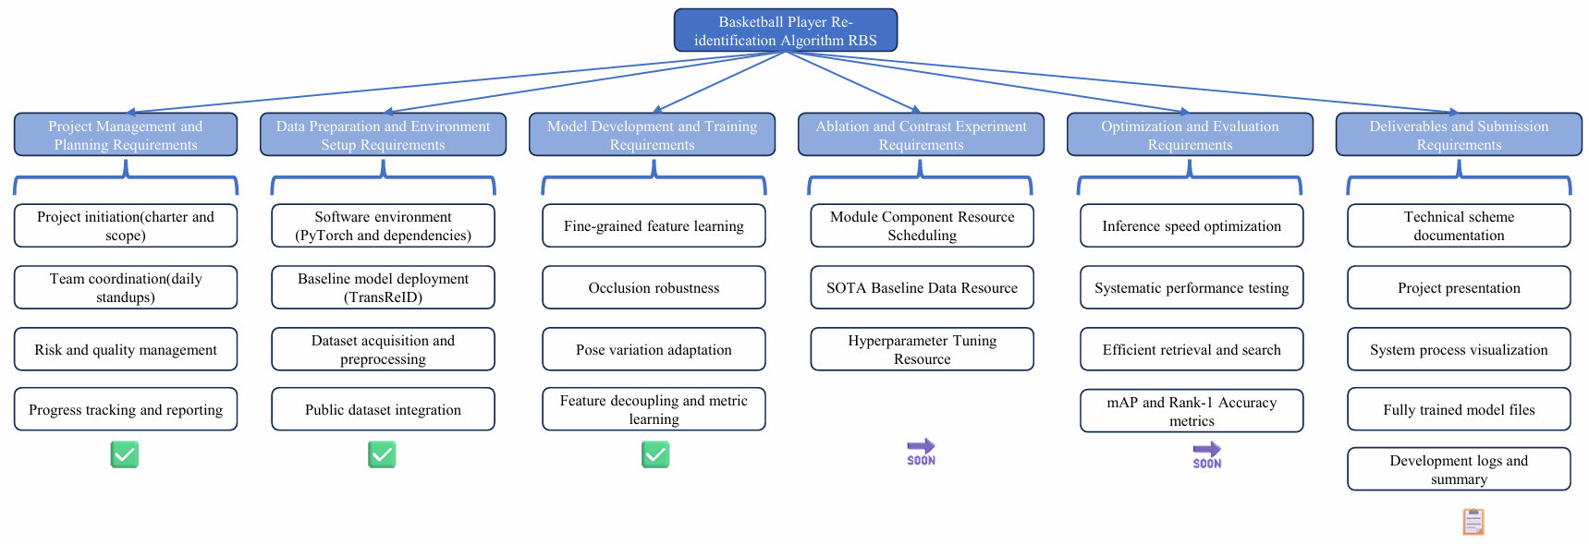
WBS:
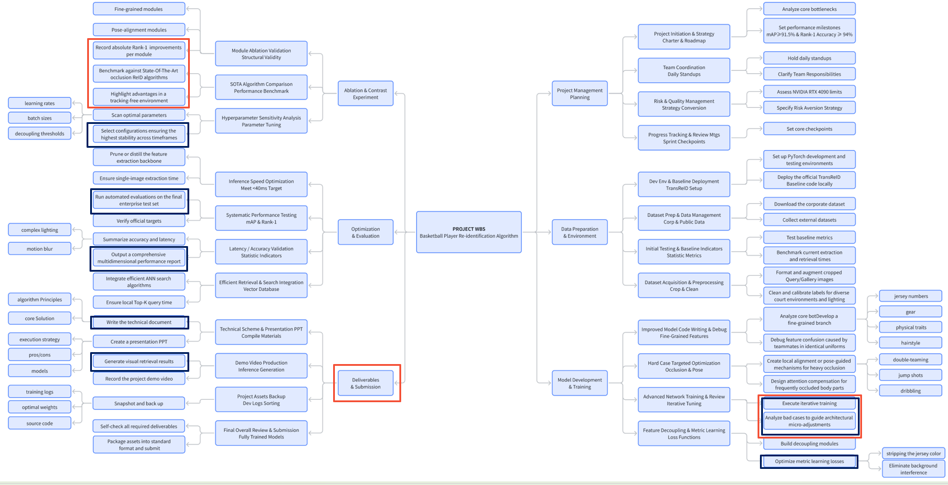
The Resource Breakdown Structure (RBS) was updated after the competition phase ended. The project focus has gradually shifted from model development to performance validation and final delivery. Therefore, System Process Visualization was added to improve the clarity of the presentation materials. Furthermore, resources were reserved for mAP and Rank-1 Accuracy evaluation in Week 15 and Ablation and Contrast Experiments in Week 16, including baseline comparison, module validation, and hyperparameter analysis.
For the updated Work Breakdown Structure (WBS), since Milestone Meeting 1, most project activities have been concentrated in the modules highlighted in blue, mainly involving model development, optimization, debugging, and performance analysis. As the project approaches completion, the focus will shift to the modules highlighted in red. These tasks mainly consist of ablation studies, state-of-the-art baseline comparisons, technical documentation, presentation preparation, and final project submission.
Code Quality Analysis (Overall Score: 7.2/10)
1. Executive Summary
This project implements a Transformer-based object re-identification algorithm for basketball player tracking in complex motion scenes. The codebase demonstrates strong architectural foundation with clear separation of concerns, comprehensive data augmentation strategies, and production-grade training pipelines. However, there are critical gaps in testing, error handling, and documentation.
2. Code Quality Dimensions: Detailed Evidence
2.1 Testing & Quality Assurance: Score 2/10 (CRITICAL)
1. No test directory exists. Running "find . -type d -name tests" and "find . -name test_*.py" both produce no output.
2. No unittest or pytest imports in any source file. No file in the project imports unittest, pytest, or any testing framework.
3. loss/center_loss.py contains a manual smoke test (lines 57-67), the closest thing to a test in the codebase, but it has no assertions:
# loss/center_loss.py:57-67
if __name__ == '__main__':
use_gpu = False
center_loss = CenterLoss(use_gpu=use_gpu)
features = torch.rand(16, 2048)
targets = torch.Tensor([0,1,2,3,2,3,1,4,5,3,2,1,0,0,5,4]).long()
loss = center_loss(features, targets)
print(loss) # No assertion - just prints the value
Impact: Any code change can introduce silent bugs. Regression testing is impossible. Refactoring is risky because there is no safety net.
Recommendation: Implement pytest-based unit tests for all core modules at the highest priority.
2.2 Error Handling: Score 5/10 (HIGH)
E1. Bare "except:" swallows all exceptions
Two files use bare except: clauses that silently catch everything, including KeyboardInterrupt and SystemExit:
model/make_model.py:16-20 -- shuffle_unit():
try:
x = x.view(batchsize, group, -1, dim)
except: # <-- Bare except
x = torch.cat([x, x[:, -2:-1, :]], dim=1)
x = x.view(batchsize, group, -1, dim)
model/backbones/vit_pytorch.py:429-433 -- load_param():
try:
self.state_dict()[k].copy_(v)
except: # <-- Bare except
print('===ERROR===')
print('shape do not match in k:{}: param_dict{} vs self.state_dict(){}'
.format(k, v.shape, self.state_dict()[k].shape))
E2. Model weight loading has zero error handling
test.py:46 -- model.load_param(cfg.TEST.WEIGHT) -- No try/except. If the weight file is missing or corrupted, the program crashes with no context.
ensemble_test.py:85 -- model.load_param(weight_path) -- Same issue. Weight loading occurs inside a loop with no error recovery:
# ensemble_test.py:82-86
for i, weight_path in enumerate(weight_list):
logger.info('Loading model {}: {}'.format(i+1, weight_path))
model = make_model(cfg, ...)
model.load_param(weight_path) # <-- No try/except
model.to(device)
E3. read_image() silently loops forever on persistent IO errors
datasets/bases.py:16-22:
while not got_img:
try:
img = Image.open(img_path).convert('RGB')
got_img = True
except IOError:
print('IOError incurred when reading {}. Will redo.'
.format(img_path))
pass
This infinite loop never terminates if the file is persistently corrupted.
E4. check_isfile() returns False instead of raising
utils/iotools.py:23-26:
def check_isfile(path):
isfile = osp.isfile(path)
if not isfile:
print('=> Warning: no file found at {} (ignored)'.format(path))
return isfile
Callers receive False and proceed with invalid paths instead of handling the error.
E5. Only 4 try/except blocks in all core modules
A grep for "except" across core modules (excluding .venv) found only 4 locations:
- model/backbones/vit_pytorch.py:431 -- bare except
- model/make_model.py:18 -- bare except
- datasets/bases.py:20 -- except IOError
- utils/iotools.py:18 -- except OSError
Impact: Silent failures, hard-to-debug crashes, and potential data corruption.
2.3 Documentation: Score 6/10 (MEDIUM)
E6. Key utility functions have no docstrings
utils/meter.py:1-2 -- AverageMeter class has only a bare comment:
class AverageMeter(object):
"""Computes and stores the average and current value"""
model/make_model.py:8-25 -- shuffle_unit() has no docstring at all.
utils/iotools.py:30-39 -- read_json() and write_json() have no docstrings.
E7. 18 source files use print() instead of proper logging
Files using print() instead of the configured logger:
File | Example Line
model/make_model.py:66 | print('using resnet50 as a backbone')
loss/make_loss.py:30 | print("using triplet loss with margin:{}")
processor/processor.py:35 | print('Using {} GPUs for training')
solver/make_optimizer.py:17 | print('Using two times learning rate for fc')
utils/iotools.py:26 | print('=> Warning: no file found at {} (ignored)')
utils/metrics.py:111 | print('The test feature is normalized')
datasets/make_dataloader.py:103 | print('using softmax sampler')
datasets/bases.py:61-67 | print('Dataset statistics:') -- entire block

E8. No Sphinx/pdoc configuration or API documentation generator
There is no docs/conf.py, no pyproject.toml doc configuration, and no CI for building docs.
2.4 Code Structure & Architecture: Score 8.5/10
E9. processor.py mixes training, evaluation, and inference logic
do_train() (lines 12-144) and do_inference() (lines 147-191) are all in one file with no separation. Training concerns (EMA initialization, checkpoint saving) are interleaved with per-batch evaluation logic.
E10. loss/make_loss.py defines loss_func inline with deeply nested logic
loss/make_loss.py:44-98 -- The loss_func() closure is 55 lines with 4 levels of nesting:
# loss/make_loss.py:43-98 (simplified structure)
elif cfg.DATALOADER.SAMPLER == 'softmax_triplet':
def loss_func(score, feat, target, target_cam):
if cfg.MODEL.METRIC_LOSS_TYPE in ('triplet','triplet_center'):
if cfg.MODEL.IF_LABELSMOOTH == 'on':
if isinstance(score, list): # Level 3
# ...
else:
# ...
if isinstance(feat, list): # Level 3
# ...
if 'center' in ...: # Level 3
# ...
else: # IF_LABELSMOOTH = 'off'
# IDENTICAL pattern repeated (lines 73-98)
if isinstance(score, list):
# ...
if isinstance(feat, list):
# ...
The if and else branches (lines 45-72 and 73-98) are near-duplicates differing only in whether they use xent() or F.cross_entropy().
2.5 Code Readability: Score 7/10 (MEDIUM)
E11. Magic numbers throughout the code
File:Line | Value | Context
processor/processor.py:44 | 0.9998 | EMA decay
solver/make_optimizer.py:16 | 2 | FC layer LR multiplier
loss/make_loss.py:18,20,22 | 384, 768, 2048 | Feature dimensions
utils/reranking.py:125 | k1=20, k2=6, lambda=0.3 | Re-ranking defaults
gui/model_thread.py:289 | 1.0 / (1.0 + dist) | Similarity norm
datasets/preprocessing.py:20 | (0.4914, 0.4822, 0.4465) | RandomErasing mean

E12. Deeply nested control flow
- loss/make_loss.py:44-98 -- loss_func() has 4 levels of nesting.
- processor/processor.py:98-143 -- Checkpoint/eval has 3 levels of if/else.
E13. Mixed Chinese and English comments
datasets/make_dataloader.py:18:
# collate_fn...list...batch size...
# list...__getitem__...
2.6 Code Duplication: Score 7.5/10 (MEDIUM)
E14. Test-Time Augmentation (TTA) logic duplicated 5 times
The pattern "normalize -> flip -> extract features -> normalize -> average -> normalize" appears in:
Location | Lines
processor/processor.py: do_inference() | 176-184
ensemble_test.py: extract_features_with_tta() | 32-43
gui/model_thread.py: GalleryFeatureExtractorThread.run() | 183-192
gui/model_thread.py: QuerySearchThread.run() | 249-258
gui/model_thread.py: BatchEvaluationThread.run() | 349-357

All five instances perform the same sequence:
# Repeated 5x -- varies only by variable names
feat = model(img, cam_label=cam_labels, view_label=view_labels)
feat = torch.nn.functional.normalize(feat, dim=1, p=2)
feat_flip = model(torch.flip(img, dims=[3]), cam_label=cam_labels, view_label=view_labels)
feat_flip = torch.nn.functional.normalize(feat_flip, dim=1, p=2)
feat = (feat + feat_flip) / 2.0
E15. isinstance(score/list) and isinstance(feat/list) checks repeated 6x
In loss/make_loss.py: lines 47-48, 54-55, 66-67 (labelsmooth=on) and lines 74-75, 81-82, 91-92 (labelsmooth=off).
Impact: Maintenance cost is multiplied -- any change to TTA logic requires updating 5+ locations.
2.7 Security & Reliability: Score 6/10 (MEDIUM)
E16. No input validation on file paths
- test.py:46 -- model.load_param(cfg.TEST.WEIGHT) accepts any string without validation.
- ensemble_test.py:56 -- args.weights.split(',') -- no validation each part is a real path.
- visualize_aug.py:29 -- Image.open(img_path) -- no try/except for corrupted images.
E17. Environment variable injection from config
test.py:41 and ensemble_test.py:74:
os.environ['CUDA_VISIBLE_DEVICES'] = cfg.MODEL.DEVICE_ID
Treats config values as safe without sanitization.
E18. ImageFile.LOAD_TRUNCATED_IMAGES = True as module-level side-effect
datasets/bases.py:7:
ImageFile.LOAD_TRUNCATED_IMAGES = True
This global setting applies silently to all PIL operations in the process.
2.8 Performance & Scalability: Score 8/10
Strengths (with evidence):
- Distributed training (DDP): processor/processor.py:34-36
- Mixed precision (AMP): processor/processor.py:42,61
- Batch processing: processor/processor.py:170
- GPU cache clearing: processor/processor.py:128,144
E19. No performance profiling or benchmarking infrastructure
- No benchmark scripts exist
- No torch.profiler usage in any file
- No throughput or latency measurements
- Training speed logged (line 95 in processor.py) but not stored across runs
3. Critical Issues: Detailed
Issue 1: No Test Coverage (CRITICAL)
Evidence:
- Zero test files in the project
- Zero test framework imports
- test.py and ensemble_test.py are manual run scripts, not automated tests
- loss/center_loss.py:57-67 smoke test uses print() not assertions
Impact: Any code change can silently break functionality. Regression testing is impossible.
Recommendation: Create tests/ directory with pytest-based test suite. Target: 60% code coverage within 2 weeks, 80% within 3 months.
Issue 2: Incomplete Error Handling (HIGH)
Evidence:
- 2 bare except: clauses (model/make_model.py:18, vit_pytorch.py:431)
- Only 4 try/except blocks in all core modules (vs. 18 files using print())
- model.load_param() calls in test.py:46, ensemble_test.py:85 have no error handling
- read_image() in datasets/bases.py:16-22 has an infinite retry loop
Recommendation: Add specific try/except blocks with custom exceptions. Replace bare except: with specific exception types.
Issue 3: Code Duplication in TTA Logic (MEDIUM)
Evidence: The TTA pattern appears verbatim in 5 locations:
- processor/processor.py:176-184
- ensemble_test.py:32-43
- gui/model_thread.py:183-192
- gui/model_thread.py:249-258
- gui/model_thread.py:349-357
Recommendation: Create utils/tta.py with reusable apply_tta() function.
Issue 4: print() Instead of Logger (MEDIUM)
Evidence: 18 source files use print() instead of the configured logging system:
- model/make_model.py:66,72
- loss/make_loss.py:27,30,33,37,100-101,104-105
- processor/processor.py:35
- solver/make_optimizer.py:17
- utils/iotools.py:26
- utils/metrics.py:111
- datasets/bases.py:61-67
- datasets/make_dataloader.py:85,103,109
Recommendation: Replace all print() calls with logger.info(), logger.warning(), or logger.error().
4. Recommendations
Immediate Actions (1-2 weeks)
# | Action | Files Affected
1 | Create test suite for core modules | New tests/ directory
2 | Replace bare except: with specific types | model/make_model.py:18, vit_pytorch.py:431
3 | Add error handling to load_param() | test.py:46, ensemble_test.py:85
4 | Extract apply_tta() utility | New utils/tta.py

Short-term Actions (1 month)
# | Action | Files Affected
5 | Replace all print() with logger | 18 files (listed in E7)
6 | Add docstrings to all public functions | All core modules
7 | Extract magic numbers to constants | processor.py:44, loss/make_loss.py:18-22, etc.
8 | Add input validation for paths/config | test.py, ensemble_test.py
9 | Set up pre-commit hooks | Root directory

5. Conclusion
This codebase demonstrates strong foundational quality with clear architecture, good separation of concerns, and comprehensive feature implementation for the basketball ReID task. The most significant gap is the complete absence of automated testing (0% coverage), followed by inconsistent error handling and documentation.
With focused effort on the immediate actions listed above, the code quality can be improved from 7.2/10 to 9/10 or higher, enabling the project to scale to larger competitions and potential production deployment.
Appendix A: File Inventory - Quality Issues at a Glance
File | Lines | Issues Found
processor/processor.py | 193 | print() (line 35); no try/except on training; TTA dup (176-184)
loss/make_loss.py | 109 | print() (6 places); nested closure (44-98); dup isinstance (6x)
model/make_model.py | 449 | Bare except (line 18); print() (66,72); missing docstrings
model/backbones/vit_pytorch.py | 532 | Bare except (line 431); no docstrings on helpers
datasets/bases.py | 86 | Infinite retry (16-22); print() (61-67); global side-effect (line 7)
datasets/make_dataloader.py | 121 | print() (85,103,109); Chinese comments (line 18)
datasets/preprocessing.py | 264 | Magic numbers (line 20); redundant conversions
test.py | 70 | No try/except on load_param (line 46); no assertions
ensemble_test.py | 152 | No try/except on load_param (line 85); TTA dup
gui/model_thread.py | 376 | TTA dup 3x (lines 183, 249, 349)
gui/widgets.py | 257 | Hardcoded styling; magic numbers for dimensions
utils/iotools.py | 40 | Silent failure in check_isfile (line 26); print()
utils/metrics.py | 134 | print() (111,124,127); no type hints
utils/meter.py | 20 | Minimal docstrings; no type hints
visualize_aug.py | 101 | No try/except on image open (line 29); print()
solver/make_optimizer.py | 29 | print() (line 17); magic number for LR (line 16)
loss/center_loss.py | 68 | Manual smoke test with print() not assertions (57-67)

Appendix B: Actions Checklist
[CRITICAL] Create tests/ with pytest
[HIGH] Replace bare except: in model/make_model.py:18
[HIGH] Replace bare except: in model/backbones/vit_pytorch.py:431
[HIGH] Add try/except to model.load_param() in test.py:46 and ensemble_test.py:85
[MEDIUM] Extract apply_tta() utility (affects 5 locations)
[MEDIUM] Replace print() with logger in 18 files
[MEDIUM] Extract magic numbers to named constants
[MEDIUM] Add docstrings to all public functions
[LOW] Add type hints to all function signatures
[LOW] Add Sphinx/pdoc configuration for API docs
[LOW] Add pre-commit hooks (black, flake8, isort)
Signatures of Reviewers:
